A000-US-MA-Swampscott-Hafted Pointed Blade-Spades and Canoe Anchor- Lithic-7,000 BP

US-MA-Swampscott-Hafted Pointed Blade-Spades and Canoe Anchor- Lithic-7,000 BP

**Case no.: 11**

**Accession Numbers:**

**Formal Label:**

US-MA-Swampscott-Hafted Pointed Blade-Spades and Canoe Anchor- Lithic-7,000 BP

**Display Description:**

These large spades and a canoe anchor were used for clamming and fishing in the littoral level off Swampscott, MA

**LC Classification: E 78**

**Date or Time Horizon:** 7,000 BP

**Geographical Area:** **late archaic, marine oriented people on the central New England coast who became the historic Massachusett First Nation. Their sachem lived in a bark wigwam where the present Anthony’s Restaurant is currently in 201.**

**Map:**

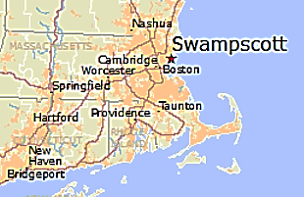 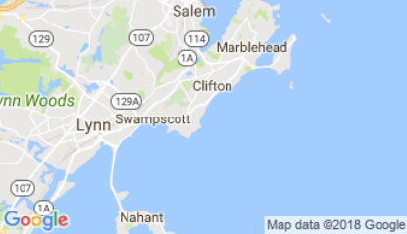

**GPS coordinates:**

**Cultural Affiliation:** late archaic, marine oriented people on the central New England coast

**Media:** No 1. Basalt; Nos.. 2, 4, 5, andesite; No. 3 granite.

**Dimensions:**

**Weight:**

**Condition: original**

**Provenance:** Swampscott, MA

**Discussion:**

**References:**

Robinson, Brian S. 1985. ***The Nelson Island and Seabrook marsh sites : late archaic, marine oriented people on the central New England coast / by Brian S. Robinson. Ceramic analysis in the northeast : contributions to methodology and culture history* / edited by James B. Petersen.** Rindge, N.H. : Fund for Anthropology, Dept. of Anthropology, Franklin Pierce College.